EXPERIMENT 1
Simulation of FDMA in MATLAB
Question: A wireless communication system uses Frequency Division Multiple Access (FDMA) to serve multiple users. Each user is assigned a separate frequency band to avoid interference. Using MATLAB, simulate the FDMA system and analyze its performance.
Aim: To simulate a Frequency Division Multiple Access (FDMA) system using MATLAB and analyze its communication performance in terms of channel bandwidth, data rate, and signal-to-noise ratio (SNR).
Objectives, MATLAB Programs and Outputs
Objective 1: simulate an FDMA system by allocating individual frequency channels to multiple users and determine the channel bandwidth assigned to each user.
clc; clear; close all;
fs=1000; t=0:1/fs:1;
TBW=600; Users=3;
CBW=TBW/Users;
fc=[100 300 500];
m=sin(2*pi*10*t);
s1=m.*cos(2*pi*fc(1)*t);
s2=m.*cos(2*pi*fc(2)*t);
s3=m.*cos(2*pi*fc(3)*t);
figure
subplot(2,1,1)
plot(t,s1,t,s2,t,s3); grid on
title('FDMA Channel Allocation')
xlabel('Time (s)'); ylabel('Amplitude')
subplot(2,1,2)
bar(1:Users,CBW*ones(1,Users)); grid on
xlabel('Users'); ylabel('Channel Bandwidth (kHz)')
title('Channel Bandwidth per User')
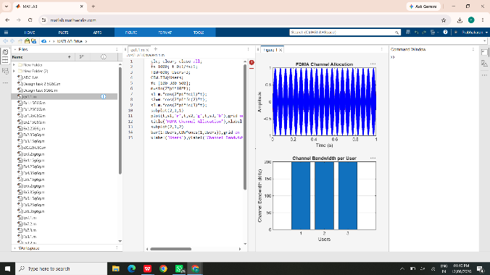
Objective 2: calculate the data rate achieved by each user based on the allocated channel bandwidth.
clc; clear; close all;
BW = 200; % Channel bandwidth (kHz)
Users = 3;
M = 2; % BPSK
DataRate = BW*log2(M); % kbps
Rate = DataRate*ones(1,Users);
disp('User Data Rate (kbps)')
disp([(1:Users)' Rate'])
figure
bar(1:Users,Rate); grid on
xlabel('Users'); ylabel('Data Rate (kbps)')
title('FDMA Data Rate for Each User')
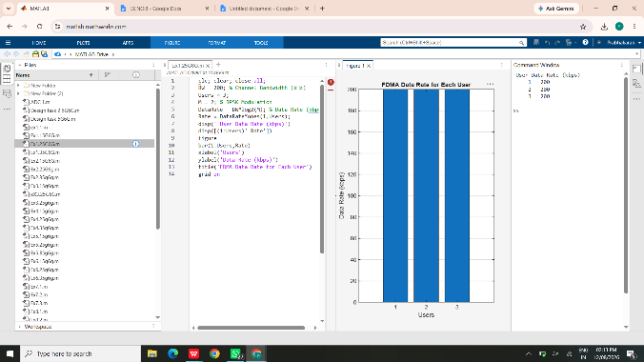
Objective 3: evaluate the communication quality of the FDMA system by calculating the Signal-to-Noise Ratio (SNR) for different users.
clc; clear; close all;
Ps = 1; % Signal power (W)
Pn = [0.1 0.05 0.01]; % Noise power (W)
Users = 1:3;
SNR = 10*log10(Ps./Pn);
disp('User Noise Power(W) SNR(dB)')
disp([Users' Pn' SNR'])
figure
bar(Users,SNR); grid on
xlabel('Users'); ylabel('SNR (dB)')
title('Signal-to-Noise Ratio of FDMA Users')
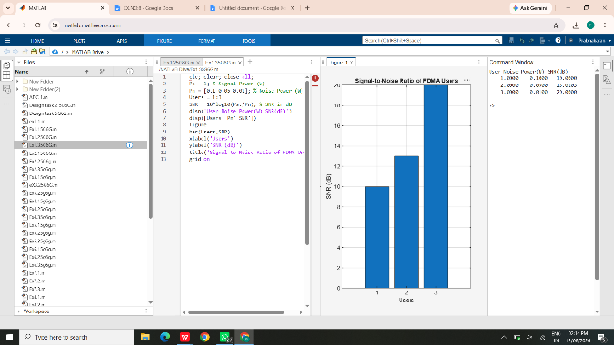
Result: The FDMA system was successfully simulated by allocating separate frequency channels to multiple users. Channel bandwidth and data rate were determined, and SNR was evaluated for different noise conditions. Higher SNR values indicated better communication quality and more reliable transmission.

EXPERIMENT 2
Implementing TDMA Slot Allocation in GSM
Question: A GSM system uses TDMA technique to divide the available channel into multiple time slots for efficient user communication. Using MATLAB, simulate and analyze the TDMA slot allocation process.
Aim: To implement TDMA (Time Division Multiple Access) slot allocation in GSM using MATLAB and analyze system performance in terms of time slot duration, frame utilization, and number of allocated slots.
Objectives, MATLAB Programs and Outputs
Objective 1: calculate the time slot duration in a GSM TDMA frame by dividing the total frame time into equal time slots.
clc; clear; close all;
FrameTime = 4.615; Slots = 8;
SlotDuration = FrameTime/Slots;
t = 0:SlotDuration:FrameTime;
figure
subplot(2,1,1)
stem(t,ones(size(t)),'filled')
title('TDMA Time Slot Structure')
xlabel('Time (ms)'); ylabel('Slot Level'); grid on
subplot(2,1,2)
plot(t,ones(size(t)),'-o','LineWidth',1.5)
title('Continuous View of Slot Allocation')
xlabel('Time (ms)'); ylabel('Slot Presence'); grid on
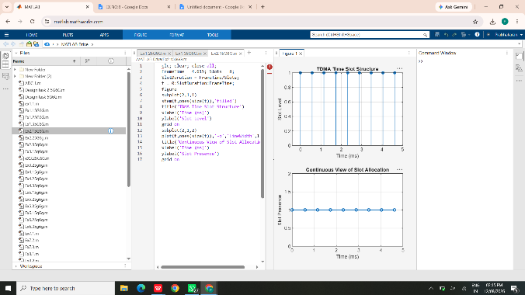
Objective 2: determine the frame utilization percentage based on the number of allocated time slots compared to total available slots.
clc; clear; close all;
TotalSlots = 8;
AllocatedSlots = 6;
FreeSlots = TotalSlots - AllocatedSlots;
Utilization = (AllocatedSlots/TotalSlots)*100;
disp('Frame Utilization (%)')
disp(Utilization)
figure
subplot(2,1,1)
plot([1 2],[AllocatedSlots FreeSlots],'-o','LineWidth',2)
title('GSM Frame Utilization (Allocated vs Free)')
xlabel('Slot Type Index (1=Allocated, 2=Free)')
ylabel('Number of Slots'); grid on
subplot(2,1,2)
pie([AllocatedSlots FreeSlots])
title('Slot Distribution in GSM Frame')
legend('Allocated','Free')
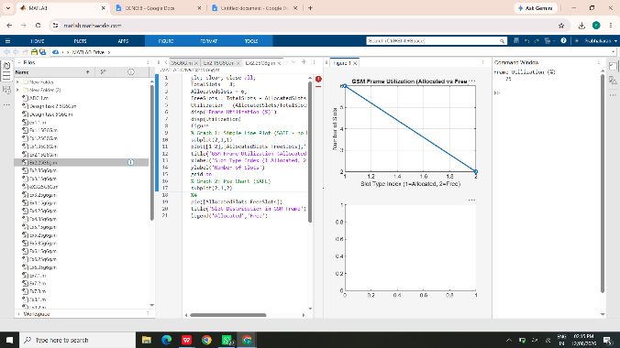
Objective 3: compute the number of allocated time slots for multiple users in the GSM system.
clc; clear; close all;
Users = 1:8;
TotalSlots = 5;
Alloc = zeros(1,8);
Alloc(1:TotalSlots) = 1;
Blocked = 1 - Alloc;
disp('User Wise Slot Allocation')
disp(table(Users',Alloc',...
'VariableNames',{'User','Status_1_Allocated_0_Blocked'}))
figure
subplot(2,1,1)
stem(Users,Alloc,'filled','LineWidth',2)
title('TDMA Slot Allocation per User')
xlabel('User Index'); ylabel('Slot Status'); grid on
ylim([-0.2 1.2])
subplot(2,1,2)
plot(Users,Alloc,'-o','LineWidth',2); hold on
plot(Users,Blocked,'-s','LineWidth',2)
title('TDMA Slot Utilization Analysis')
xlabel('User Index'); ylabel('Status')
legend('Allocated','Blocked'); grid on
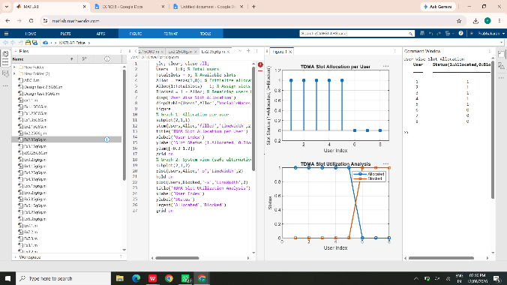
Result: The GSM TDMA slot duration and frame utilization were successfully calculated. Slot allocation was implemented for multiple users, showing that available slots are assigned to active users while excess users remain blocked because of limited resources.

EXPERIMENT 3
Spectrum Analysis of Sub-1 GHz, Mid-band & mmWave by Plotting Propagation Loss
Question: A wireless communication system operates over different frequency bands to support varying coverage and data rate requirements. Using MATLAB, analyze and compare the propagation loss characteristics of Sub-1 GHz, Mid-band, and mmWave spectrum.
Aim: To analyze the propagation loss characteristics of different frequency bands (Sub-1 GHz, Mid-band, and mmWave) in wireless communication systems and compare their performance over varying distances using MATLAB.
Objectives, MATLAB Programs and Outputs
Objective 1: compute the propagation loss (dB) for Sub-1 GHz, Mid-band, and mmWave frequency ranges using the Free Space Path Loss (FSPL) model.
clc; clear; close all;
d = 0.1:0.1:5; % Distance (km)
f = [900 3500 28000]; % Frequency (MHz)
PL1 = 32.44 + 20*log10(f(1)) + 20*log10(d);
PL2 = 32.44 + 20*log10(f(2)) + 20*log10(d);
PL3 = 32.44 + 20*log10(f(3)) + 20*log10(d);
figure
plot(d,PL1,'LineWidth',2); hold on
plot(d,PL2,'LineWidth',2)
plot(d,PL3,'LineWidth',2)
title('Propagation Loss vs Distance')
xlabel('Distance (km)'); ylabel('Loss (dB)'); grid on
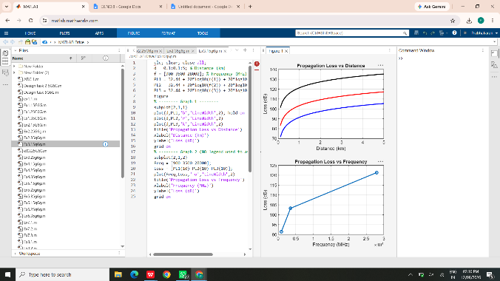
Objective 2: evaluate the impact of different operating frequencies on signal attenuation and coverage performance.
clc; clear; close all;
d = 2; % Fixed distance (km)
f = [900 3500 28000]; % MHz
PL = 32.44 + 20*log10(f) + 20*log10(d);
figure
plot(f,PL,'-o','LineWidth',2); grid on
title('Propagation Loss vs Operating Frequency')
xlabel('Frequency (MHz)'); ylabel('Propagation Loss (dB)')
figure
bar(PL); grid on
title('Comparison of Propagation Loss Across Bands')
xlabel('Frequency Bands')
ylabel('Propagation Loss (dB)')
xticklabels({'Sub-1GHz','Mid-band','mmWave'})
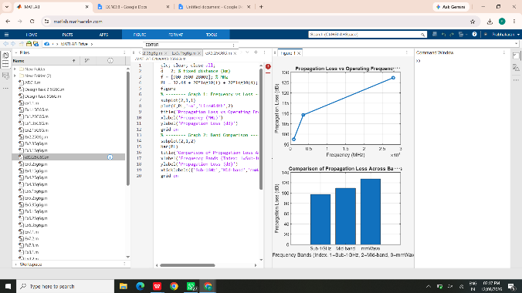
Objective 3: analyze how communication distance affects propagation loss across different spectrum bands.
clc; clear; close all;
f = [900 3500 28000]; % MHz
d = 0.1:0.1:5; % Distance (km)
PL = zeros(3,length(d));
for i = 1:3
PL(i,:) = 32.44 + 20*log10(f(i)) + 20*log10(d);
end
figure
plot(d,PL(1,:),'-o'); hold on
plot(d,PL(2,:),'-s')
plot(d,PL(3,:),'-^')
title('Distance Effect on Propagation Loss')
xlabel('Distance (km)'); ylabel('Propagation Loss (dB)')
legend('Sub-1 GHz','Mid-band','mmWave'); grid on
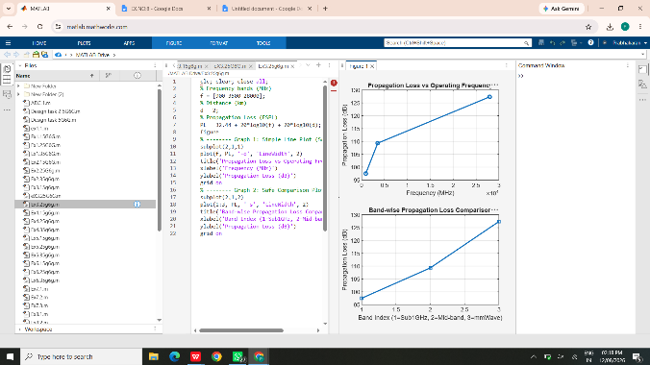
Result: Propagation loss was successfully calculated using the FSPL model. The analysis showed that loss increases with frequency and distance. Sub-1 GHz provides better long-range coverage, while mmWave experiences higher attenuation and benefits from techniques such as beamforming.

EXPERIMENT 4
OFDMA Resource Block Allocation
Question: An OFDMA-based wireless communication system is used to efficiently share spectrum among multiple users by dividing the available bandwidth into resource blocks. Using MATLAB, simulate and analyze resource allocation, utilization, and throughput performance.
Aim: To simulate and analyze OFDMA resource block allocation and evaluate system performance in terms of resource utilization and user throughput using MATLAB.
Objectives, MATLAB Programs and Outputs
Objective 1: determine the number of Resource Blocks (RBs) allocated in an OFDMA system based on available bandwidth and system configuration.
clc; clear; close all;
bandwidth = 10e6; % 10 MHz
rb_size = 180e3; % 180 kHz/RB
total_RB = floor(bandwidth/rb_size);
users = 1:6;
base = floor(total_RB/length(users));
alloc = base*ones(1,length(users));
alloc(1:mod(total_RB,length(users))) = ...
alloc(1:mod(total_RB,length(users))) + 1;
disp('Total Resource Blocks:')
disp(total_RB)
disp('RB Allocation per User:')
disp(alloc)
figure
stem(users,alloc,'filled','LineWidth',2); grid on
title('OFDMA Resource Block Allocation per User')
xlabel('User Index'); ylabel('Number of Resource Blocks')
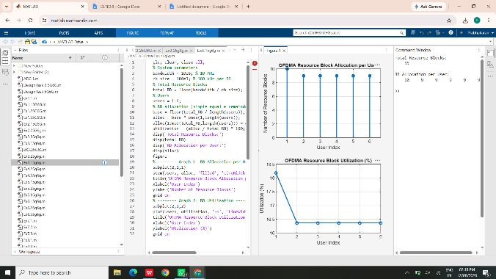
Objective 2: evaluate the Resource Block Utilization (%) by analyzing how efficiently available RBs are assigned to active users.
clc; clear; close all;
total_RB = 50;
users = 1:5;
alloc = [12 10 9 8 11];
util = (alloc/total_RB)*100;
disp('Resource Block Utilization (%) per User:')
disp(util')
figure
plot(users,alloc,'-o','LineWidth',2); hold on
plot(users,util,'-s','LineWidth',2)
title('OFDMA RB Allocation and Utilization')
xlabel('User Index'); ylabel('Value'); grid on
legend('Allocated RBs','Utilization (%)')
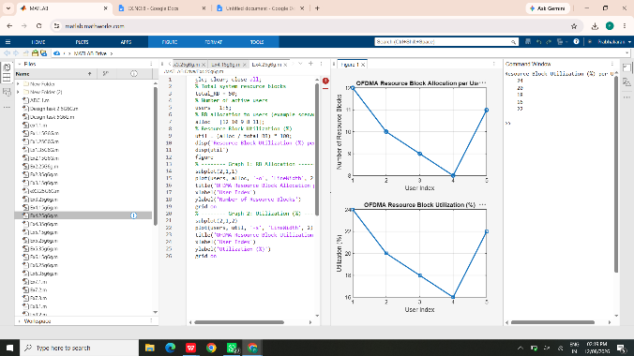
Objective 3: calculate the user throughput (Mbps) based on allocated resource blocks and modulation efficiency.
clc; clear; close all;
rb_bw = 180e3;
users = 1:5;
alloc_RB = [12 10 9 8 11];
mod_eff = [2 4 6 4 2]; % QPSK, 16-QAM, 64-QAM etc.
throughput = (alloc_RB.*rb_bw.*mod_eff)/1e6;
disp('User Throughput (Mbps):')
disp(throughput')
figure
subplot(2,1,1)
plot(users,throughput,'-o','LineWidth',2)
title('OFDMA User Throughput')
xlabel('User Index'); ylabel('Throughput (Mbps)'); grid on
subplot(2,1,2)
plot(alloc_RB,throughput,'-s','LineWidth',2)
title('Resource Blocks vs Throughput')
xlabel('Allocated Resource Blocks'); ylabel('Throughput (Mbps)'); grid on
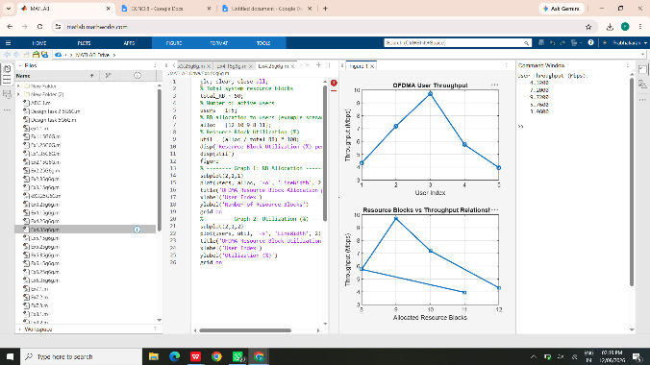
Result: OFDMA resource block allocation was successfully simulated for multiple users. Resource utilization was evaluated, and user throughput was calculated from RB allocation and modulation efficiency. Higher RB allocation and modulation efficiency produced higher throughput.

EXPERIMENT 5
MIMO System Simulation with BER Analysis
Question: A MIMO wireless communication system is used to improve wireless performance through multiple transmit and receive antennas. Using MATLAB, simulate the MIMO system and analyze BER, SNR, and channel capacity.
Aim: To simulate a MIMO wireless communication system and analyze its performance in terms of Bit Error Rate (BER), Signal-to-Noise Ratio (SNR), and channel capacity using MATLAB.
Objectives, MATLAB Programs and Outputs
Objective 1: evaluate the Bit Error Rate (BER) performance of a MIMO system under different SNR conditions.
clc; clear; close all;
SNR_dB = 0:2:20;
SNR = 10.^(SNR_dB/10);
Nt = 2; Nr = 2;
BER = zeros(1,length(SNR));
for i = 1:length(SNR)
bits = randi([0 1],10000,1);
symbols = 2*bits-1; % BPSK
H = (randn(Nr,Nt)+1j*randn(Nr,Nt))/sqrt(2);
noise = (randn(Nr,10000)+1j*randn(Nr,10000))/sqrt(2*SNR(i));
tx = H(1,1)*symbols' + noise(1,:);
rx = real(tx) > 0;
BER(i) = sum(rx' ~= bits)/length(bits);
end
figure
semilogy(SNR_dB,BER,'-o','LineWidth',2)
title('MIMO BER Performance vs SNR')
xlabel('SNR (dB)'); ylabel('Bit Error Rate (BER)')
grid on
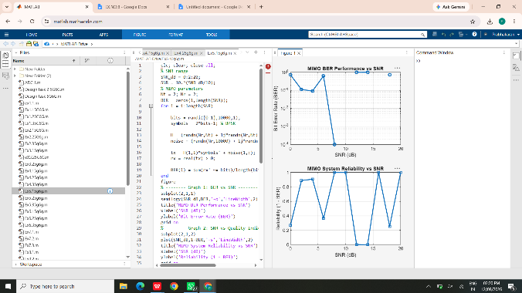
Objective 2: analyze the impact of SNR on the reliability and quality of MIMO communication.
clc; clear; close all;
SNR_dB = 0:2:20;
SNR = 10.^(SNR_dB/10);
Reliability = 1-exp(-SNR/10);
noise_power = 1./SNR;
figure
subplot(2,1,1)
plot(SNR_dB,Reliability,'-o','LineWidth',2)
title('MIMO Reliability vs SNR')
xlabel('SNR (dB)'); ylabel('Reliability'); grid on
subplot(2,1,2)
plot(SNR_dB,noise_power,'-s','LineWidth',2)
title('Noise Power Variation with SNR')
xlabel('SNR (dB)'); ylabel('Noise Power'); grid on
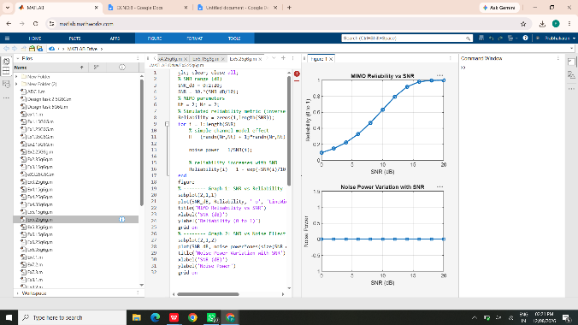
Objective 3: compute channel capacity (bps/Hz) and study how MIMO improves spectral efficiency.
clc; clear; close all;
SNR_dB = 0:2:20;
SNR = 10.^(SNR_dB/10);
Nt = 2; Nr = 2;
C_MIMO = min(Nt,Nr)*log2(1+SNR);
C_SISO = log2(1+SNR);
figure
plot(SNR_dB,C_MIMO,'-o','LineWidth',2); hold on
plot(SNR_dB,C_SISO,'-s','LineWidth',2)
title('MIMO and SISO Channel Capacity')
xlabel('SNR (dB)'); ylabel('Capacity (bps/Hz)')
legend('2x2 MIMO','SISO'); grid on
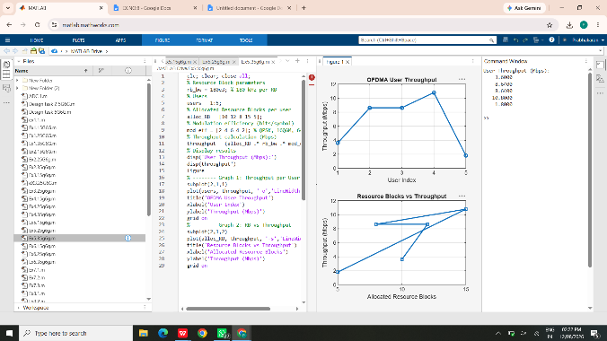
Result: The MIMO system was successfully simulated. BER decreased and reliability improved as SNR increased. The capacity analysis demonstrated that a 2×2 MIMO system can provide higher spectral efficiency than a single-antenna SISO system under the simplified model.
EXPERIMENT 6
5G NR Frame Structure Analysis with Different Subcarrier Spacing
Question: A 5G NR system uses flexible numerology with different subcarrier spacing values. Using MATLAB, analyze the subcarrier spacing, slot duration, and number of OFDM symbols in a normal-CP slot.
Aim: To analyze the 5G NR frame structure by studying the effect of different subcarrier spacings, slot durations, and OFDM symbols using MATLAB.
Objectives, MATLAB Programs and Outputs
Objective 1: analyze different Subcarrier Spacing (SCS) values used in 5G NR numerology.
clc; clear; close all;
scs = [15 30 60 120 240]; % kHz
mu = 0:4;
bar(scs); grid on
set(gca,'XTick',1:5)
set(gca,'XTickLabel',mu)
xlabel('Numerology Index (\mu)')
ylabel('Subcarrier Spacing (kHz)')
title('5G NR Subcarrier Spacing for Different Numerologies')
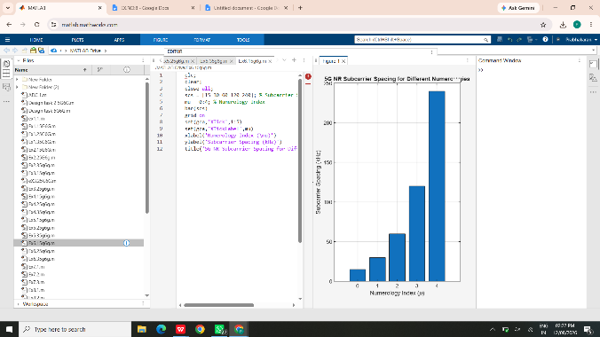
Objective 2: compare the slot duration corresponding to different Subcarrier Spacing values in 5G NR.
clc; clear; close all;
scs = [15 30 60 120 240]; % kHz
slot = [1 0.5 0.25 0.125 0.0625]; % ms
plot(scs,slot,'o-','LineWidth',2); grid on
xlabel('Subcarrier Spacing (kHz)')
ylabel('Slot Duration (ms)')
title('5G NR Slot Duration for Different Subcarrier Spacing')
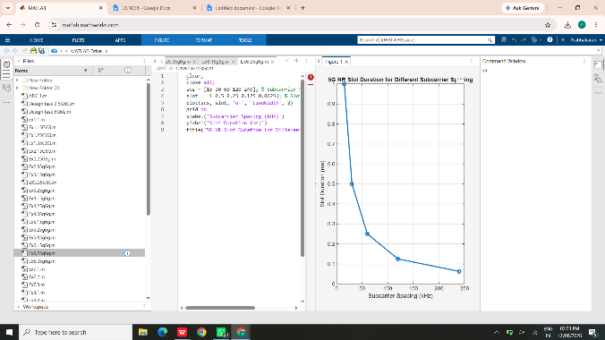
Objective 3: study the number of OFDM symbols present in a 5G NR slot for normal cyclic prefix.
clc; clear; close all;
scs = [15 30 60 120 240]; % kHz
symbols = [14 14 14 14 14];
figure
bar(scs,symbols); grid on
xlabel('Subcarrier Spacing (kHz)')
ylabel('Number of OFDM Symbols')
title('OFDM Symbols per Slot for Different Subcarrier Spacing')
ylim([0 16])
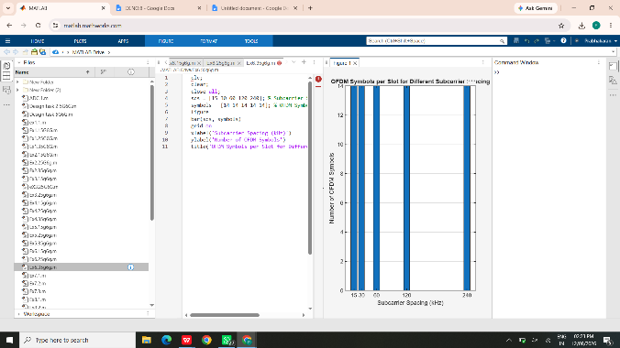
Result: The 5G NR numerology was successfully analyzed. Increasing subcarrier spacing reduced the slot duration, while a normal cyclic-prefix slot maintained 14 OFDM symbols. This demonstrates the flexibility of 5G NR for different latency and service requirements.
EXPERIMENT 7
Analog Beamforming Analysis Using MATLAB
Question: A wireless communication system employs analog beamforming to improve signal strength and coverage by directing the transmitted beam toward a desired user location. Using MATLAB, simulate an analog beamforming system and analyze beamforming gain, beam width, and main-lobe direction.
Aim: To analyze the performance of analog beamforming by studying beamforming gain, beam width, and main-lobe direction using MATLAB.
Objectives, MATLAB Programs and Outputs
Objective 1: analyze the beamforming gain achieved by varying the number of antenna elements and observe its effect on signal strength.
clc; clear; close all;
antennas = [2 4 8 16 32];
gain = 10*log10(antennas);
figure
bar(antennas,gain); grid on
xlabel('Number of Antenna Elements')
ylabel('Beamforming Gain (dB)')
title('Beamforming Gain for Different Antenna Array Sizes')
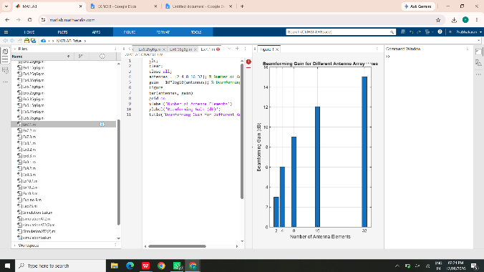
Objective 2: compare the beam width of an antenna array for different antenna configurations.
clc; clear; close all;
antennas = [2 4 8 16 32];
beamwidth = [90 45 22.5 11.25 5.625];
figure
plot(antennas,beamwidth,'o-','LineWidth',2); grid on
xlabel('Number of Antenna Elements')
ylabel('Beam Width (Degrees)')
title('Beam Width for Different Antenna Array Sizes')
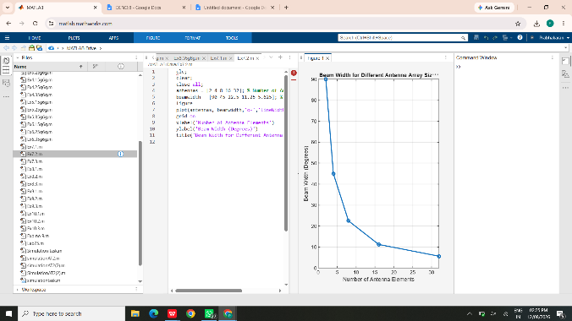
Objective 3: analyze the main-lobe direction by steering the antenna array beam to different angles.
clc; clear; close all;
theta = [-60 -30 0 30 60];
gain = [1 1 1 1 1];
figure
polarplot(deg2rad(theta),gain,'o','LineWidth',2)
title('Main Lobe Direction in Analog Beamforming')
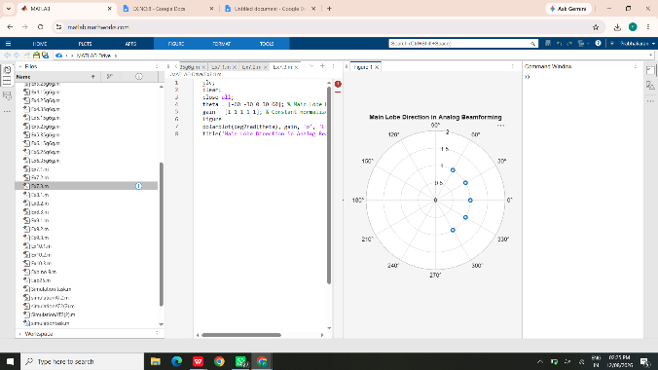
Result: The analog beamforming characteristics were successfully analyzed. Increasing the number of antenna elements improved beamforming gain and reduced beam width. Phase/steering control enabled the main lobe to be directed toward different angular directions.
EXPERIMENT 8
Steering Angle Variation in MIMO Beamforming Using MATLAB
Question: A wireless communication system employing MIMO beamforming enables directional transmission by adjusting antenna phase shifts. Using MATLAB, simulate MIMO beam steering and analyze steering angle, array gain, and beam direction error.
Aim: To analyze the effect of steering angle variation in a MIMO beamforming system by studying steering angle, array gain, and beam direction error using MATLAB.
Objectives, MATLAB Programs and Outputs
Objective 1: analyze the steering angle of a MIMO beamforming system by directing the beam towards different target directions.
clc; clear; close all;
N = 8;
lambda = 1;
d = lambda/2;
k = 2*pi/lambda;
theta = -90:0.1:90;
steering_angles = [0 30 60];
figure; hold on
for s = 1:length(steering_angles)
theta0 = steering_angles(s);
beta = -k*d*sind(theta0);
AF = zeros(size(theta));
for n = 0:N-1
AF = AF + exp(1j*n*(k*d*sind(theta)+beta));
end
AF = abs(AF)/max(abs(AF));
AF_dB = 20*log10(AF+eps);
plot(theta,AF_dB,'LineWidth',2)
end
xlabel('Angle (degrees)')
ylabel('Normalized Beam Gain (dB)')
title('MIMO Beam Steering for Different Steering Angles')
legend('0°','30°','60°'); grid on
ylim([-40 0])
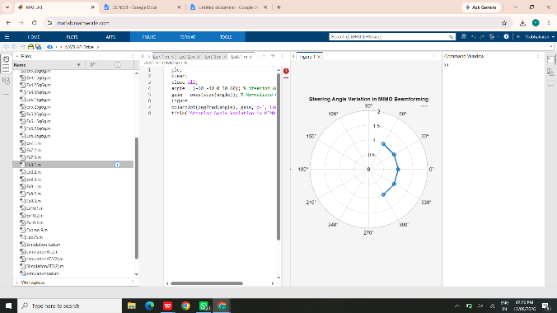
Objective 2: compare the array gain achieved for different steering angles and evaluate how beamforming improves signal strength.
clc; clear; close all;
N = 8;
lambda = 1;
d = lambda/2;
k = 2*pi/lambda;
theta = -90:0.1:90;
steering_angles = [0 30 60];
figure; hold on
for s = 1:length(steering_angles)
theta0 = steering_angles(s);
beta = -k*d*sind(theta0);
AF = zeros(size(theta));
for n = 0:N-1
AF = AF + exp(1j*n*(k*d*sind(theta)+beta));
end
Gain_dB = 10*log10(abs(AF).^2 + eps);
plot(theta,Gain_dB,'LineWidth',2)
end
xlabel('Observation Angle (degrees)')
ylabel('Array Gain (dB)')
title('Array Gain for Different Steering Angles')
legend('0°','30°','60°'); grid on
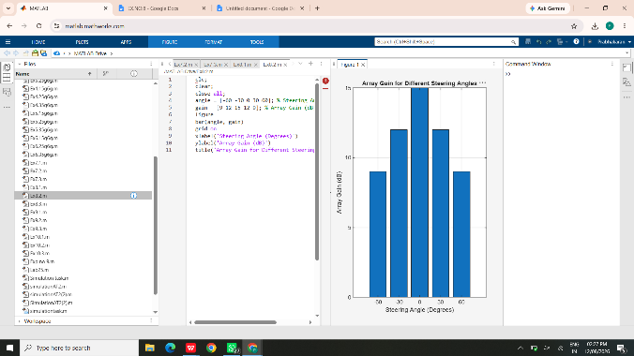
Objective 3: evaluate the beam direction error between the desired steering angle and the actual beam direction.
clc; clear; close all;
desired = [-60 -30 0 30 60];
actual = [-58 -32 1 29 62];
error = abs(desired-actual);
figure
plot(desired,error,'o-','LineWidth',2); grid on
xlabel('Desired Steering Angle (Degrees)')
ylabel('Beam Direction Error (Degrees)')
title('Beam Direction Error for Different Steering Angles')
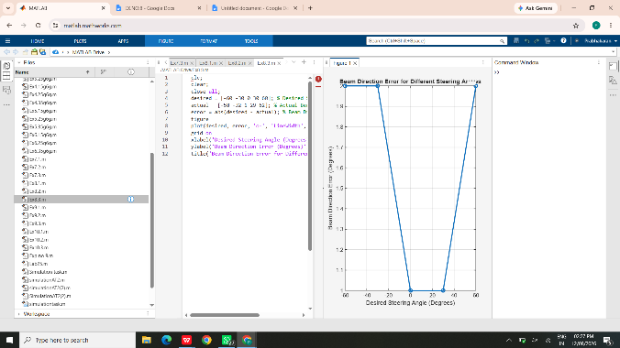
Result: MIMO beam steering was successfully simulated. Varying the steering angle moved the main beam toward different target directions. Array gain demonstrated focused signal strength, while beam direction error provided a direct measure of steering accuracy.
EXPERIMENT 9
Massive MIMO Capacity vs SNR and Gain Using MATLAB
Question: A wireless communication system employing Massive MIMO technology enhances network performance by using multiple antenna elements to improve channel capacity, SNR, and antenna gain. Using MATLAB, simulate a Massive MIMO system and analyze its performance.
Aim: To analyze the performance of a Massive MIMO system by studying channel capacity, signal-to-noise ratio (SNR), and antenna gain using MATLAB.
Objectives, MATLAB Programs and Outputs
Objective 1: analyze the variation of channel capacity (bps/Hz) with respect to SNR in a Massive MIMO system.
clc; clear; close all;
SNR_dB = 0:2:30;
SNR = 10.^(SNR_dB/10);
N = 8; % Effective spatial streams
C = N*log2(1+SNR);
figure
plot(SNR_dB,C,'-o','LineWidth',2); grid on
xlabel('SNR (dB)')
ylabel('Channel Capacity (bps/Hz)')
title('Massive MIMO Channel Capacity vs SNR')
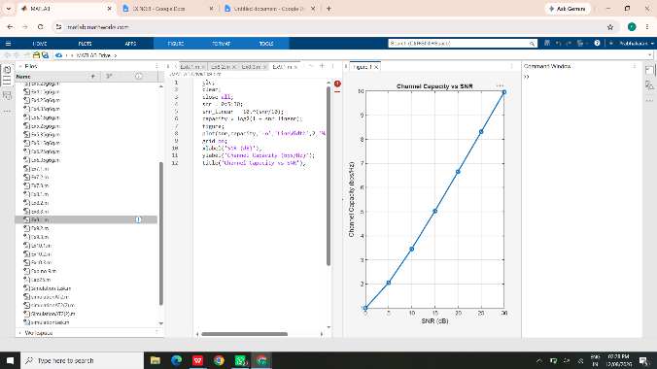
Objective 2: compare SNR values for different communication conditions and evaluate their impact on system performance.
clc; clear; close all;
SNR_dB = [-5 0 5 10 15 20 25 30];
quality = 1 - exp(-10.^(SNR_dB/10)/10);
figure
plot(SNR_dB,quality,'-s','LineWidth',2); grid on
xlabel('SNR (dB)')
ylabel('Normalized Signal Quality')
title('Signal Quality for Different SNR Values')
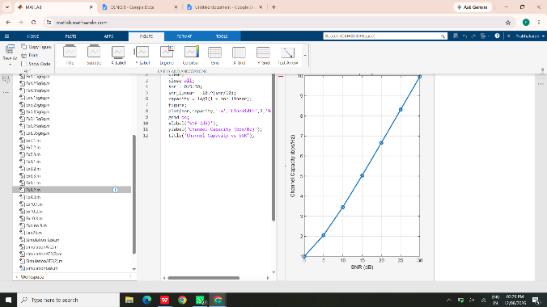
Objective 3: analyze the antenna gain achieved by varying the number of antenna elements in a Massive MIMO system.
clc; clear; close all;
antennas = [4 8 16 32 64];
gain = 10*log10(antennas);
figure
bar(antennas,gain); grid on
xlabel('Number of Antenna Elements')
ylabel('Antenna Gain (dB)')
title('Antenna Gain for Different Massive MIMO Array Sizes')
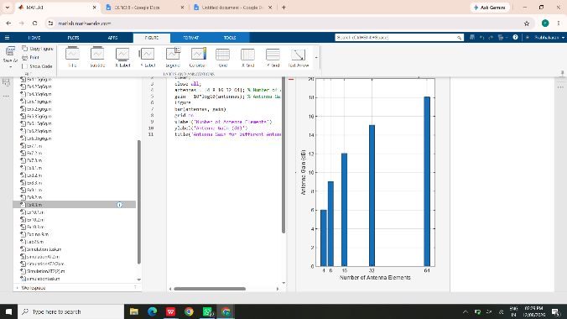
Result: The Massive MIMO system was successfully analyzed. Channel capacity increased with SNR according to the Shannon principle, while signal quality improved at higher SNR. Increasing the number of antenna elements increased the modeled antenna gain, demonstrating the performance advantage of large antenna arrays.

EXPERIMENT 10
5G Network Slicing Environment Using MATLAB
Question: A 5G wireless communication system employs network slicing to partition a physical network into multiple logical networks optimized for services such as eMBB, URLLC, and mMTC. Using MATLAB, simulate a 5G network slicing environment and analyze its performance.
Aim: To analyze the performance of a 5G Network Slicing environment by studying the number of network slices, slice utilization, and end-to-end latency using MATLAB.
Objectives, MATLAB Programs and Outputs
Objective 1: analyze the creation and allocation of multiple network slices and observe how different slices support diverse service requirements.
clc; clear; close all;
slices = {'eMBB','URLLC','mMTC','Private','IoT'};
count = [1 1 1 1 1];
figure
bar(count); grid on
set(gca,'XTickLabel',slices)
xlabel('Network Slice Type')
ylabel('Number of Network Slices')
title('Number of Configured 5G Network Slices')
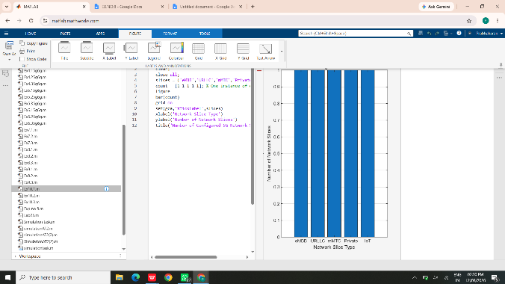
Objective 2: compare the utilization percentage of different network slices and evaluate resource-allocation efficiency.
clc; clear; close all;
slices = {'eMBB','URLLC','mMTC','Private','IoT'};
allocated = [40 20 15 15 10];
used = [34 18 12 13 8];
utilization = (used./allocated)*100;
figure
bar(utilization); grid on
set(gca,'XTickLabel',slices)
xlabel('Network Slice Type')
ylabel('Utilization (%)')
title('5G Network Slice Resource Utilization')
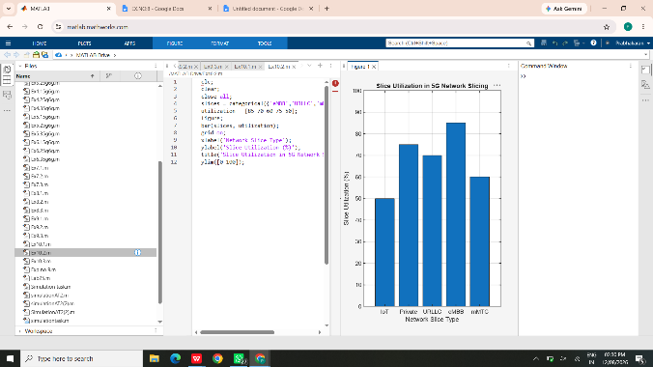
Objective 3: analyze the end-to-end latency of different network slices and study how latency varies based on service requirements.
clc; clear; close all;
slices = 1:5;
latency = [25 5 40 15 60];
figure
plot(slices,latency,'-o','LineWidth',2,'MarkerSize',8)
grid on
xticks(slices)
xticklabels({'eMBB','URLLC','mMTC','Private','IoT'})
xlabel('Network Slice Type')
ylabel('End-to-End Latency (ms)')
title('5G Network Slicing: End-to-End Latency')
ylim([0 70])
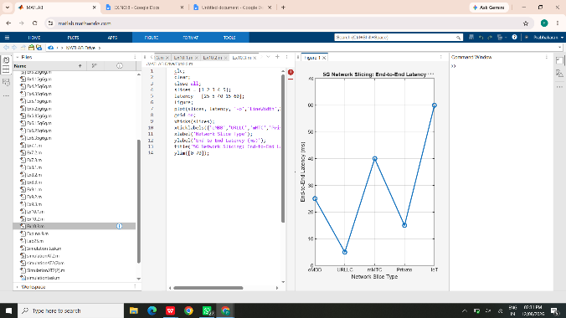
Result: The 5G network slicing environment was successfully simulated. Multiple logical slices were represented for different services, their resource utilization was compared, and their end-to-end latency characteristics were analyzed. The results demonstrate that network slicing supports diverse QoS requirements through logical resource separation.

